Ben Brandhorst

CMIS 242

March 31st, 2019

**Project 1**

|  |  |  |  |
| --- | --- | --- | --- |
| **INPUT** | **EXPECTED OUTPUT** | **ACTUAL OUTPUT** | **PASS??** |
| **Scanner Input From Text File:**  2014 Employee Smith,John 2000  2014 Salesman Conner,Sarah 2500 123234  2014 Salesman Hammer,MC 10000 1000000  2015 Executive Hammil,Mark 8000 43  2015 Employee Simpson,Homer 3500 | Year: 2014  [  | Job: Employee| Name: Smith,John| Salary (monthly): 2000| Salary (annual): 24000|  ,  | Job: Salesman| Name: Conner,Sarah| Salary (monthly): 2500| Salary (annual): 32464|  ,  | Job: Salesman| Name: Hammer,MC| Salary (monthly): 10000| Salary (annual): 140000|  ]  Average 2014 Annual Salary: 65488  Year: 2015  [  | Job: Executive| Name: Hammil,Mark| Salary (monthly): 8000| Salary (annual): 96000|  ,  | Job: Employee| Name: Simpson,Homer| Salary (monthly): 3500| Salary (annual): 42000|  ]  Average 2015 Annual Salary: 69000 | Year: 2014  [  | Job: Employee| Name: Smith,John| Salary (monthly): 2000| Salary (annual): 24000|  ,  | Job: Salesman| Name: Conner,Sarah| Salary (monthly): 2500| Salary (annual): 32464|  ,  | Job: Salesman| Name: Hammer,MC| Salary (monthly): 10000| Salary (annual): 140000|  ]  Average 2014 Annual Salary: 65488  Year: 2015  [  | Job: Executive| Name: Hammil,Mark| Salary (monthly): 8000| Salary (annual): 96000|  ,  | Job: Employee| Name: Simpson,Homer| Salary (monthly): 3500| Salary (annual): 42000|  ]  Average 2015 Annual Salary: 69000 | YES |
| **Scanner Input From Text File:**  2014 Executive Holmes,Sherlock 5000 55  2014 Employee Hanks,Tom 2345  2015 Executive Dre,Dr 100000 100  2015 Salesman Mays,Billy 4000 430000  2015 Employee Simpson,Lisa 500 | Year: 2014  [  | Job: Executive| Name: Holmes,Sherlock| Salary (monthly): 5000| Salary (annual): 90000|  ,  | Job: Employee| Name: Hanks,Tom| Salary (monthly): 2345| Salary (annual): 28140|  ]  Average 2014 Annual Salary: 59070  Year: 2015  [  | Job: Executive| Name: Dre,Dr| Salary (monthly): 100000| Salary (annual): 1230000|  ,  | Job: Salesman| Name: Mays,Billy| Salary (monthly): 4000| Salary (annual): 56600|  ,  | Job: Employee| Name: Simpson,Lisa| Salary (monthly): 500| Salary (annual): 6000|  ]  Average 2015 Annual Salary: 430866 | Year: 2014  [  | Job: Executive| Name: Holmes,Sherlock| Salary (monthly): 5000| Salary (annual): 90000|  ,  | Job: Employee| Name: Hanks,Tom| Salary (monthly): 2345| Salary (annual): 28140|  ]  Average 2014 Annual Salary: 59070  Year: 2015  [  | Job: Executive| Name: Dre,Dr| Salary (monthly): 100000| Salary (annual): 1230000|  ,  | Job: Salesman| Name: Mays,Billy| Salary (monthly): 4000| Salary (annual): 56600|  ,  | Job: Employee| Name: Simpson,Lisa| Salary (monthly): 500| Salary (annual): 6000|  ]  Average 2015 Annual Salary: 430866 | YES |
| **Scanner Input From Text File:**  2014 Salesman Jobs,Steve 10000 555555  2015 Executive Stiles,Ryan 1000 43  2015 Employee Doe,John 9999  2015 Salesman No,Dr 3333 433333  2015 Employee Simpson,Bart 100 | Year: 2014  [  | Job: Salesman| Name: Jobs,Steve| Salary (monthly): 10000| Salary (annual): 131111|  ]  Average 2014 Annual Salary: 131111  Year: 2015  [  | Job: Executive| Name: Stiles,Ryan| Salary (monthly): 1000| Salary (annual): 12000|  ,  | Job: Employee| Name: Doe,John| Salary (monthly): 9999| Salary (annual): 119988|  ,  | Job: Salesman| Name: No,Dr| Salary (monthly): 3333| Salary (annual): 48662|  ,  | Job: Employee| Name: Simpson,Bart| Salary (monthly): 100| Salary (annual): 1200|  ]  Average 2015 Annual Salary: 45462 | Year: 2014  [  | Job: Salesman| Name: Jobs,Steve| Salary (monthly): 10000| Salary (annual): 131111|  ]  Average 2014 Annual Salary: 131111  Year: 2015  [  | Job: Executive| Name: Stiles,Ryan| Salary (monthly): 1000| Salary (annual): 12000|  ,  | Job: Employee| Name: Doe,John| Salary (monthly): 9999| Salary (annual): 119988|  ,  | Job: Salesman| Name: No,Dr| Salary (monthly): 3333| Salary (annual): 48662|  ,  | Job: Employee| Name: Simpson,Bart| Salary (monthly): 100| Salary (annual): 1200|  ]  Average 2015 Annual Salary: 45462 | YES |

**Test Case #1 Output Example:**

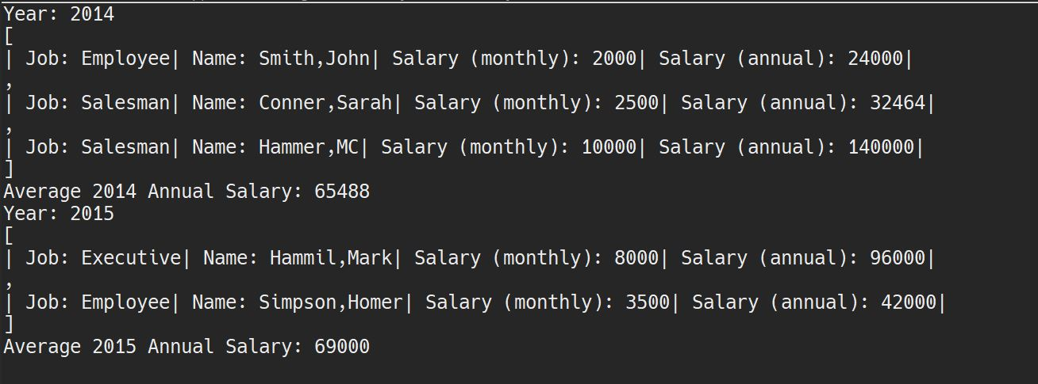

**Test Case #2 Output Example:**

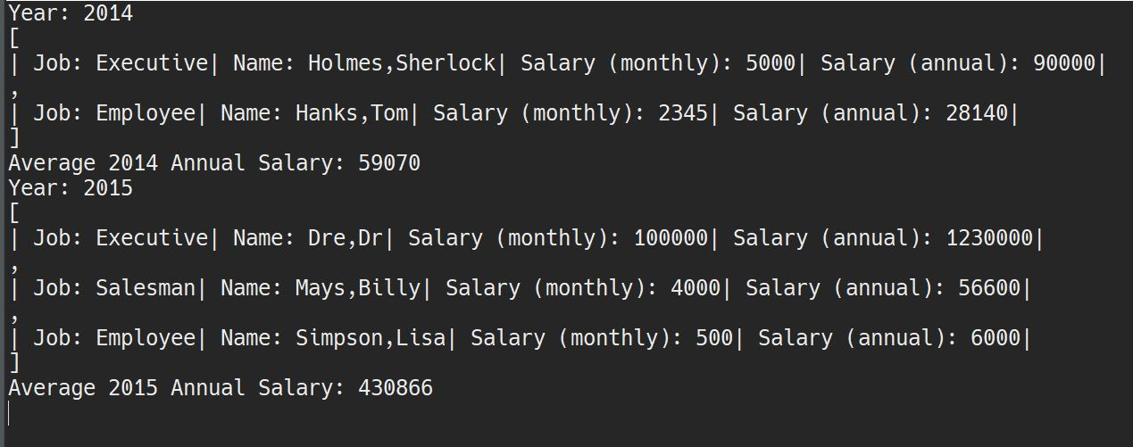

**Test Case #3 Output Example:**

